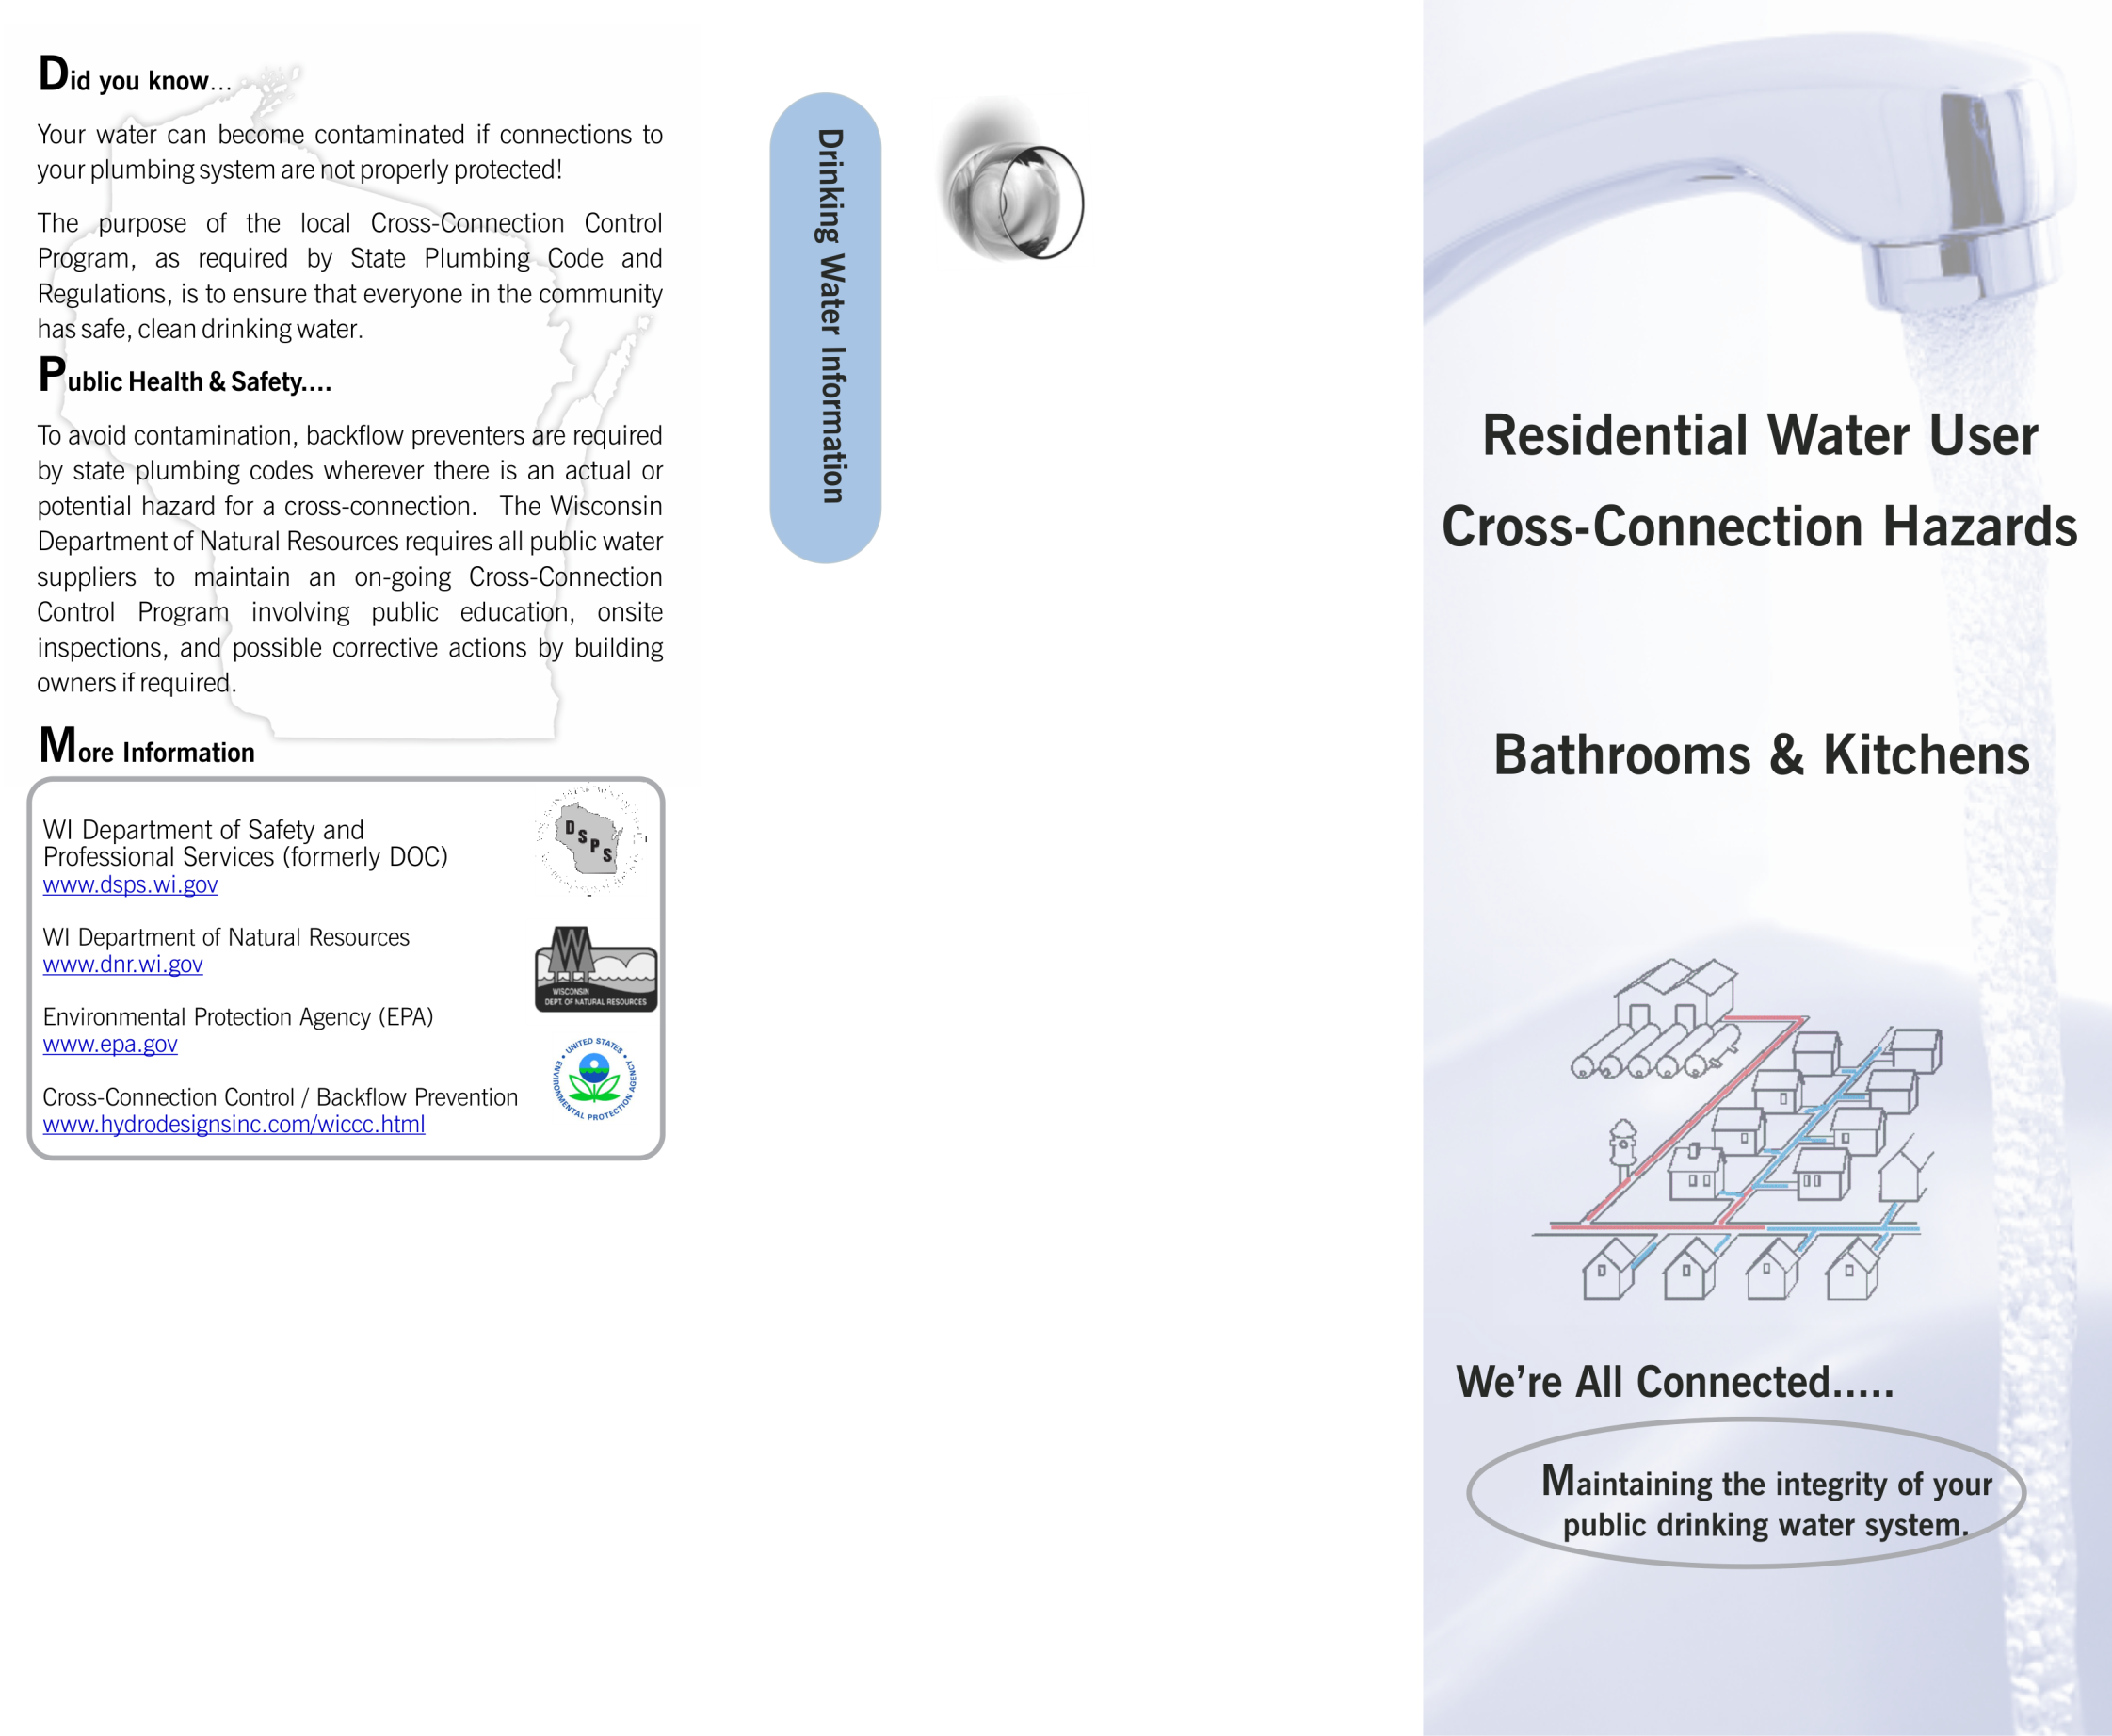
Name of water system
Address here
City, State Zip
Phone number here
Insert Return Address
Information Here
Or DELETE
Name of water system
Address here
City, State Zip
Phone number here
Website

- Use “insert picture: to add your logo…

Insert Logo, Custom Message

or

Address & Contact Information Here


